**TRAFFIC MANAGEMENT SYSTEMS**

**PHASE -1**

**TRAFFIC MANAGEMENT WITH IoT :**



**Role of IoT in Smart City Traffic Management :**

* Expand the capacity of city streets without having to build new roads.
* Optimize the traffic flow and keep the drivers safe. It would include cameras, sensors, and cellular technologies that automatically adjust traffic lights, expressway lanes, speed limits, and highway exit counters.
* Transmit accurate information about available parking spaces to citizens in real-time
* Collect data on congestion and improve traffic signaling to reduce blockages and optimize commute
* Locate incidents and report them to emergency rooms immediately with road sensors and video surveillance
* Employ real-time data feeds to ensure the streetlights turn dim or brighten up per the changing weather conditions and the onset of day and night.

## Application of IoT in Traffic Management :

City governments can improve their operations & infrastructure by placing IoT sensors and tracking devices on roads and highways for recording, analyzing, and sharing data in real-time.

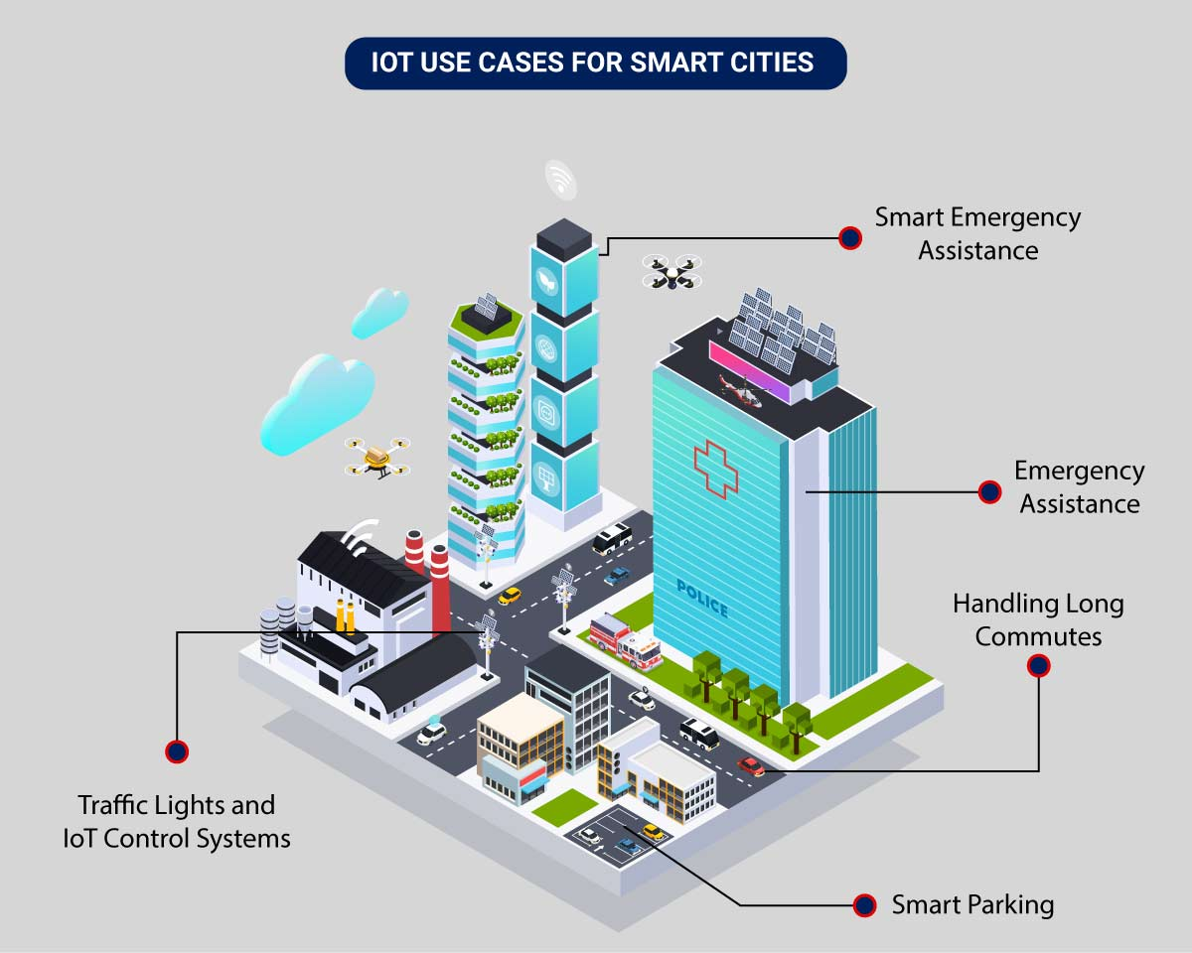

* **Traffic Lights and IoT Control Systems**: Smart traffic signals may look like a typical stoplight, yet they utilize an array of sensors to monitor real-time traffic. Usually, the goal is to help cars reduce the amount of time spent idle. And IoT technology enables the various signals to communicate with each other. This is while adapting to changing traffic conditions in real time. The outcome is less time spent in traffic jams and even reduced carbon emissions.
* **Parking Enabled through IoT**: Smart meters and mobile apps make on-street parking spaces easily accessible with instant notifications. Drivers receive alerts whenever a parking spot is available to reserve it instantly. The app gives easy directions to the parking spot with a convenient online payment option.
* **Emergency Assistance through IoT**: A traffic monitoring system using IoT technology enables emergency responders to speed up the care mechanism in case of accidents late at night or in isolated locations. The sensors on the road detect any accident, and the problem is immediately reported to the traffic management system. This request is passed on to relevant authorities to take corrective action. Emergency response personnel would include medical technicians, police officers, and fire departments for enhanced responsiveness and timely intervention.
* **Commute Assistance:**With every vehicle acting as an IoT sensor, a dedicated app can make suggestions, determine optimal routes & provide advance notice of accidents or traffic jams. Further, it can even suggest the best time to leave. It is all because of a robust algorithm that helps reduce driving time with intelligent traffic lights.